Book Review

Book Author Name. Book Title, City: Publisher, Year, Number of Pages (… p.). ISBN.

DOI: … (filled by the Journal)

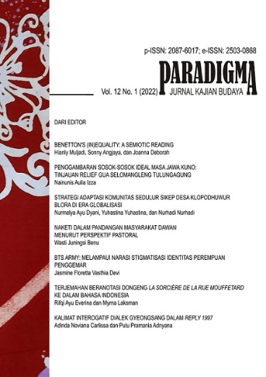
Author’s Name (Arial Narrow 12pt) paradigma@ui.ac.id (email address, Arial Narrow 12pt)
Faculty of Humanities, University of Indonesia (Affiliation, Arial Narrow 12pt)

Paradigma: Jurnal Kajian Budaya is a reviewed publication. Paradigma: Jurnal Kajian Budaya accepts original articles regarding various issues in cultural science, including but not limited to philosophy, literature, archaeology, anthropology, linguistics, history, cultural studies, philology, arts, and library and information science that focuses on useful assessment and research. This journal fairly contains various articles on high-quality theoretical, empirical, comparative, or exploratory research, including articles on undergraduate students' final assigned articles, book reviews, and a summary of the thesis/dissertation. All accepted documents—written by bachelor, magister, and doctorate students, plus graduates and experts—will be published online and in print.
The Book Review should be in Indonesian. 4–8 pages long, in A4 format, with 1.5 spacing. The book cover is high resolution, at least 300 DPI (in tiff, png, or jpg format). Name of the author, book title, city, publisher, year of publication, number of pages, ISBN. Book reviewer's name, email address, affiliation. The review includes the author's opinion regarding the book's content.

