Manuscript Writing Template for Jurnal Epidemiologi Kesehatan Indonesia (2016 Version) The title is written in two languages (Indonesian and English) using the font Times New Roman, 16 point (pt), bold, with 1.5 spacing.

Krisnawati Bantas^{1 *}, Hari Koesnanto², Budi Moelyono³ ← 12pt, bold

¹Department of Epidemiology, Faculty of Public Health Universitas Indonesia, 1st Floor, Building A Kampus Baru UI Depok 16424, Indonesia ← 12pt, italic
^{2,3} Doctoral Program in Medical and Health Sciences, Universitas Gajah Mada, Yogyakarta 55281, Indonesia ← 12pt, italic

* Corresponding Author: Krisnawati Bantas, Epidemiology Department of Epidemiology, Faculty of Public Health Universitas Indonesia, 1st Floor, Building A Kampus Baru UI Depok 16424, Indonesia, E-mail: krisnabantas@yahoo.com, Phone: +62-21-78849031

Abstract 12pt, Times New Roman bold
The abstract is written in 12 pt Times New Roman in both English and Indonesian, with a maximum of 200-250 words. The abstract must be clear, concise, and presented as a description in a single paragraph. It should contain a brief introduction to the problem and the research objective, followed by a statement of the methodology and a brief summary of the results, and conclude with a comment on the significance of the results or a brief conclusion.

Keywords 12pt, Times New Roman bold
Write 3-5 keywords separated by commas (,); proper indexing of the paper must be provided. For example: Central obesity, metabolic syndrome, urban population, waist circumference.

Introduction 12pt, Times New Roman bold
This template is designed to help authors prepare their manuscripts; it is an accurate representation of the format expected by the editors. To use this template, you can save this MS Word file for your document, then copy and paste your document here.
Jurnal Epidemiologi Kesehatan Indonesia covers epidemiology as a discipline and practice concerned with preventive measures and promotion to improve public health through a scientific approach that applies epidemiological science by examining the distribution, frequency, trends, characteristics, or patterns of diseases related to human health. Its focus covers areas such as epidemiology of communicable diseases, epidemiology of non-communicable diseases, occupational health and safety epidemiology, environmental health and biomarker epidemiology, behavioral and social epidemiology, health services epidemiology, injury epidemiology, cancer epidemiology, reproductive health epidemiology, nutritional epidemiology, perinatal epidemiology, and disaster epidemiology. The journal uses a peer-review mechanism in which every submitted article must be reviewed anonymously by expert colleagues appointed by the editor. Articles published in this journal may take the form of original articles and invited review articles.
All documents submitted to the journal must be written in good and correct Indonesian. Indonesian and English are used only in the title and abstract. The journal also checks, free of charge, whether a manuscript should or should not be published, and checks for plagiarism.
In the Introduction, the Author must state the objective of the work at the end of the introduction section. Before the objective, the Author should provide adequate background and a very brief literature survey to identify existing solutions/methods, explain the main advantages and limitations of previous studies, and explain what you did in this article in the hope of solving those limitations and demonstrating the scientific achievement or novelty of your paper. Avoid an overly detailed literature survey or a summary of the results.

Methods 12pt, Times New Roman bold
The methods include the design, population, sample, data source, techniques/instruments, data collection procedures, and data analysis procedures. The methods must enable readers to understand how the experiment was carried out, providing enough detail for readers to conduct a similar experiment, yet be written concisely and clearly. If the method follows a previously published survey, this must be indicated with a reference, with relevant modifications explained. Do not repeat details of previous methods. An ethics statement needs to be explained in the methods section; the ethical approval must include the number of the ethical clearance letter for experimental studies and other studies that require ethical review, such as the use of primary data, etc. Studies that use secondary data may provide an ethics statement concerning the permission process for using the data until the data can be used.
This paper will be published in Jurnal Epidemiologi Kesehatan Indonesia after the peer-review process and a decision of “Accepted” by the Editor. The layout of the final paper will be rearranged by the Editorial Office of Jurnal Epidemiologi Kesehatan Indonesia.

Results 12pt, Times New Roman bold
Results must be written clearly and concisely. The Results should summarize the (scientific) findings rather than provide detailed data. Authors may highlight differences between the results or findings and previous publications by other researchers. The tables or figures included in the Results must not exceed six.
Tables that are included are written sequentially with the table title and number above the table, for example: Table 1. The table title is written in 12pt bold, while the table contents are written in 10 pt font. Tables must be positioned at the center of the column or of the page. Table elements must be followed by single spacing; double spacing may be used only to indicate groupings of data or separate sections within a table. Do not show vertical lines in tables. Only horizontal lines should be shown in tables.

Table 1. Template Format
Object | Font | Alignment | Space above | Space below
Title | 12pt bold | centered | 0pt | 12pt
Author(s) | 12pt bold | centered | 12pt | 12pt
Addresses | 12pt italics | centered | 0pt | 0pt
Heading1 | 12pt bold | Left | 12pt | 3pt
Heading2 | 12pt bold | Left | 6pt | 3pt
Heading3 | 12pt bold italics | Left | 3pt | 3pt
Body | 12pt | justified | 0pt | 0pt
Bullet | 12pt | justified | 0pt | 0pt
Table title | 12pt | centered | 12pt | 6pt
Figure title | 12pt | centered | 3pt | 6pt

Figures or charts that are included are written sequentially with the figure/chart title and number below the figure/chart, as shown in Figure 1. Figures/charts must be typed and clearly legible; the use of color or black-and-white (BW) figures is permitted, and border lines around the figure are not allowed.
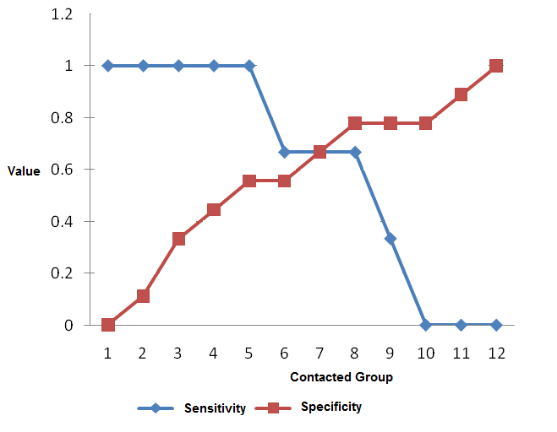

Figure 1. Example of a Figure or Chart

Discussion 12pt, Times New Roman bold
In the Discussion section, the Author must explore the meaning of the experimental results with arguments based on theories relevant to the results, without repeating the results. The Discussion is the most important part of your article. In this section, the Author has the opportunity to “sell” the data. A combined Results and Discussion section may be considered appropriate when preparing the discussion. In general, the discussion should begin with a brief summary of the main scientific findings (not the experimental results). Avoid long quotations or extensive published literature in the discussion.
The following components should be covered in the discussion: How do the experimental results relate to the original question or the objective outlined in the Introduction (what)? Do you provide a scientific interpretation for each result or finding presented (why)? Are your results consistent with what other researchers have reported (what else)? Or are there differences?

Conclusion 12pt, Times New Roman bold
The conclusion must answer the research objective. Explain how your experiment contributes to the advancement of current knowledge in the field. Without a clear conclusion, reviewers and readers will find it difficult to assess or understand your article and to see whether or not it is worth publishing in this journal. Do not repeat the Abstract or merely list the experimental results. Provide a clear scientific justification for your experiment, and you may also describe the applications and extensions of your experimental results. You should also suggest subsequent experiments and/or point out to the reader any experiments that are currently under way.

References 12pt, Times New Roman bold
References must use the Vancouver style. Please use a reference manager application such as EndNote, Mendeley, Zotero, etc. Cite only scientific publications that you have read, and refer to current journals. “et al” is used only for references with more than 6 authors. Reference numbers must be numbered sequentially.

The first letter of the reference title must be capitalized, followed by lowercase letters, except for names of people, places, and times. Titles must not be underlined and must not be written in bold.
- Haas AN, de Castro GD, Moreno T, Susin C, Albandar JM, Oppermann RV, et al. Azithromycin as a adjunctive treatment of aggressive periodontitis: 12-months randomized clinical trial. J Clin Periodontol. 2008 Aug; 35(8): 696-704. ← Journal
- Tasdemir T, Yesilyurt C, Ceyhanli KT, Celik D, Er K. Evaluation of apical filling after root canal filling by 2 different techiques. J Can Dent Assoc [Internet]. 2009 Apr [cited 2009 Jun 14];75(3):[about 5pp.]. Available from: http://www.cda-adc.ca/jcda/vol-75/issue-3/201.html. ←Journal Article from the Internet
- Diabetes Prevention Program Research Group. Hypertension, insulin, and proinsulin in of participants with impaired glucose tolerance. Hypertension. 2002; 40 (5): 679-86. ←Journal Article with an Organization as Author
- Miles DA, Van Dis ML, Williamson GF, Jensen CW. Radiographic imaging for dental team. 4th ed. St. Louis: Saunders Elsevier; 2009. ← Book
- Royal Adelaide Hospital; University of Adelaide, Department of Clinical Nursing. Compendium of nursing research and practice development, 1999-2000. Adelaide (Australia): Adelaide University; 2001. ← Book Written by an Organization or Publisher Team
- Irfan A. Protocols for predictable aesthetic dental restoration [Internet]. Oxford: Blackwell Munksgaard; 2006 [cited 2009 May 21]. Available from Netlibrary: http://cclsw2.vcc.ca:2048/login?url=http://www.netLibrary.com/urlapi.asp?actionn=summary&v=1&bookid=181691. ← Book on the Internet (E-book)
- Rusady MA. Studi eksplorasi diagnosis realted groups (DRG’s) penyakit abortus di Rumah Sakit Fatmawati tahun 2000 [thesis]. Depok: Fakultas Kesehatan Masyarakat Universitas Indonesia; 2000. ←Thesis
- American Dental Hygienists’ Association [Internet]. Chicago : American Dental Hygienists’ Association; 2009 [cited 2009 May 30]. Available from: http://www.adha.org← Website
When citing literature, Authors are required to cite the primary scientific publication, not to cite from secondary citations. Authors are also only permitted to cite items that they have read. Do not inflate the manuscript with too many references. Avoid excessive citation of publications from the same region. Check every reference against the original source (author names, volume, issue, year, DOI number). Please use a reference manager application such as EndNote, Mendeley, Zotero, etc. Use other articles published in the same journal as a model.
All publications cited in the text must be included in the reference list. Number the references sequentially as they appear in the text. Reference numbers are shown in parentheses. Make sure that every reference cited in the text is also present in the reference list (and vice versa). References cited in the abstract must be given in full. Unpublished results and those obtained from personal communication are not recommended in the reference list, but may be mentioned in the text. If these references are included in the reference list, they must follow the journal’s standard reference style and must substitute the publication date with either “unpublished results” or “personal communication”. Citing a reference as “in press” implies that the item has been accepted for publication.
If a reference is taken from a book or journal accessed through the internet, the Author must at minimum write the full URL and the date when the reference was last accessed. Further information should also be given, if known (DOI, author names, date, reference to the source publication, etc.).

Declaration Statements
This section must include the following five components:

Ethical approval: The ethical approval statement must be presented clearly, including the institution and approval number.

Acknowledgments: List here the individuals who provided assistance during the research, such as language help, writing assistance, or proofreading of the article, etc.

Conflict of interest statement: A conflict of interest statement must be included, even if the authors have no conflict of interest. If there is no conflict, the authors must state: “The authors declare that there is no conflict of interest.”

Funding: List the funding sources in this standard way to facilitate compliance with funder requirements. There is no need to include a detailed description of the program or type of grant and award. If the funding comes from block grants or other resources available to a university, college, or other research institution, list the name of the institution or organization that provided the funding. If no funding was provided for the research, please include the following sentence: “This research received no specific grant from any funding agency in the public, commercial, or not-for-profit sectors.” or “This research received no external funding.”

Data availability: List a statement of where the data can be obtained. Include a data link if available. Alternatives may be: “The derived data supporting the findings of this study are available from the corresponding author on request.” or “All data underlying the results of this study are available as part of the article and no additional source data are required.”

Author contributions
Provide at least one contribution for each author in the submission system.
Jurnal Epidemiologi Kesehatan has adopted the CRediT Taxonomy to describe each author’s contribution to the work. The submitting author is responsible for providing the contributions of all authors at the time of manuscript submission. We expect that all authors have reviewed, discussed, and agreed on their individual contributions beforehand. Contributions will be published with the final article and must accurately reflect contributions to the work.
Table. CRediT Taxonomy
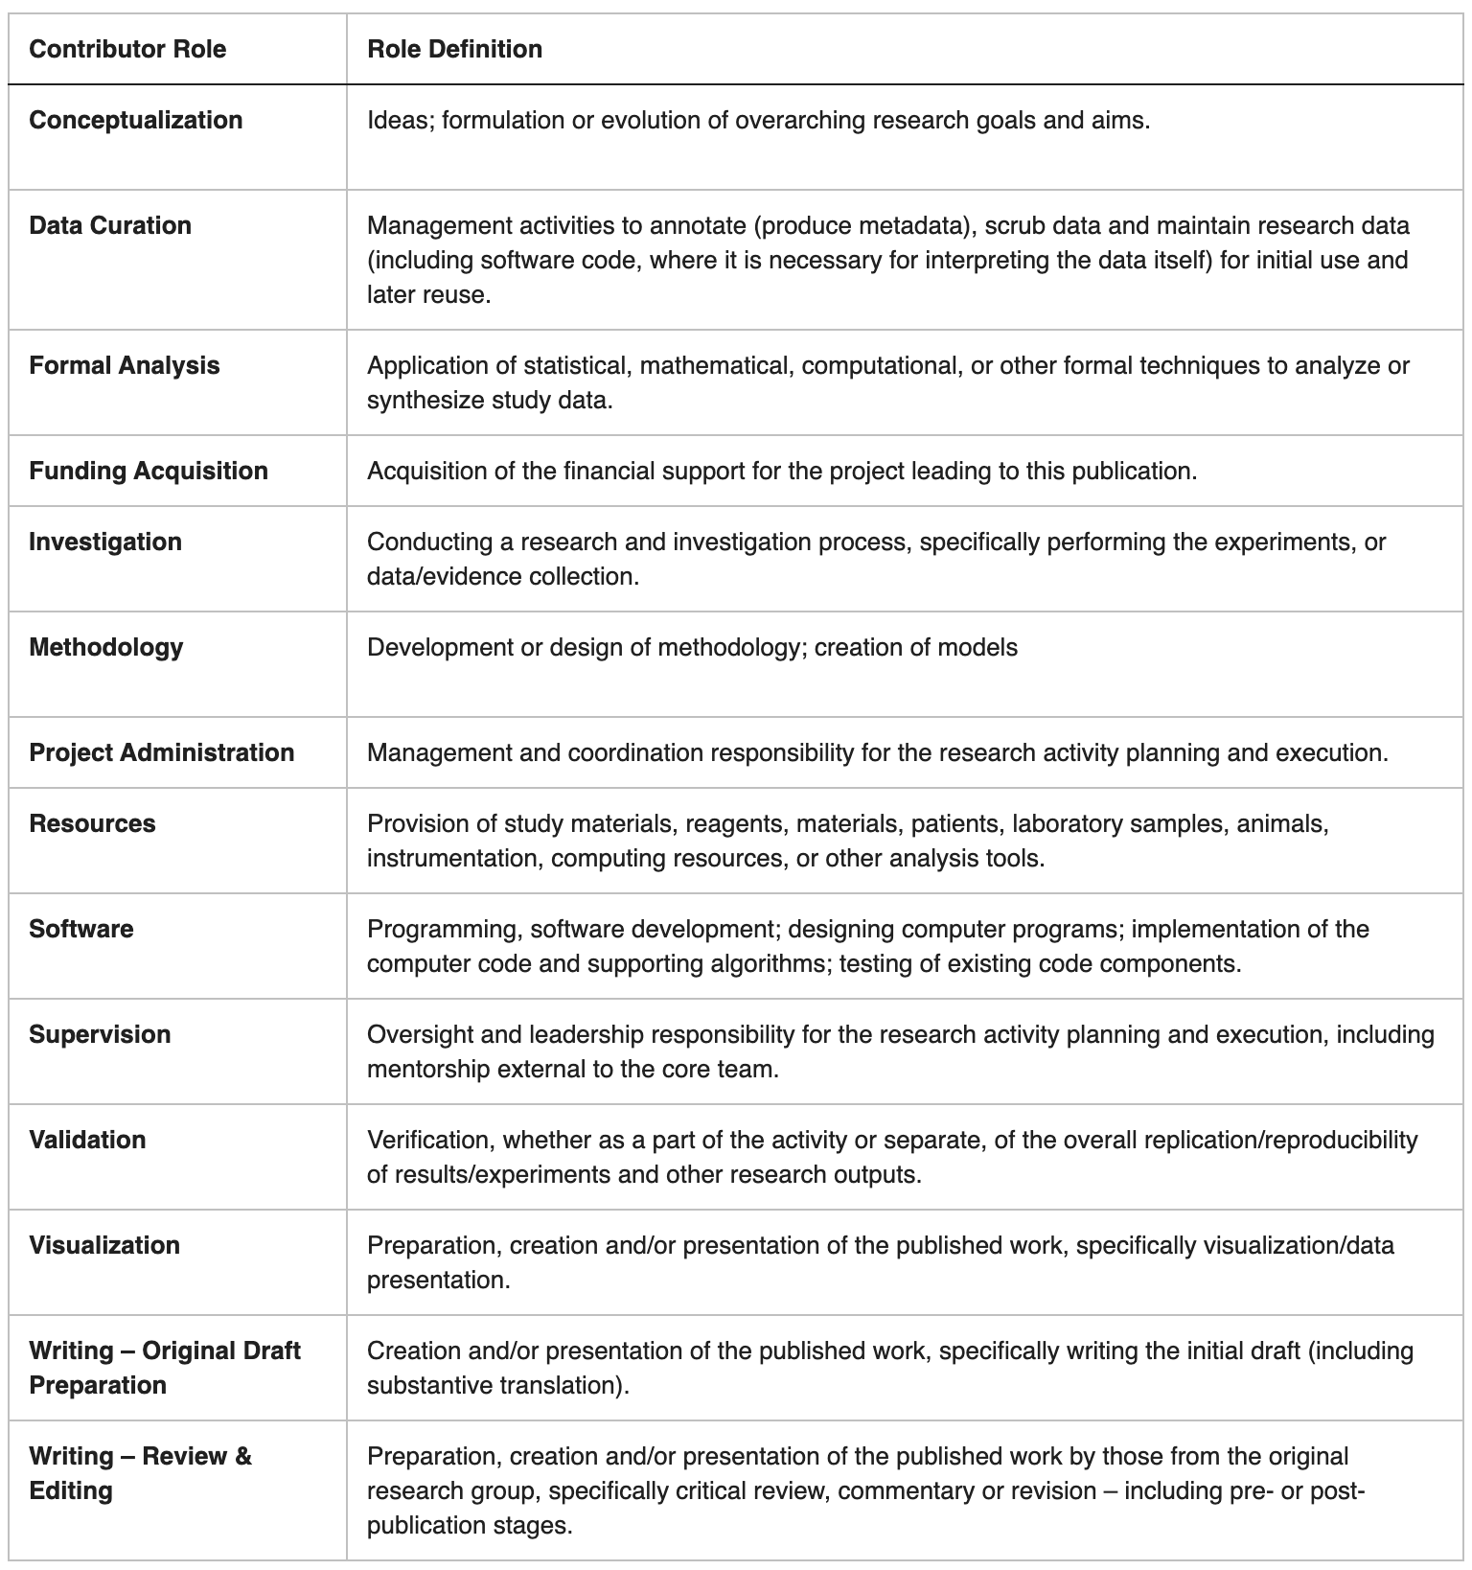

Example of an author contribution statement:
“This manuscript was originally designed by PBM and further developed by HK, AW, EA, and RM. PBM and HH made substantial contributions to the conception and design of the work. PBM and AW contributed to data analysis and access and verified the underlying data. PBM, HK, AW, EA, and RM contributed to the interpretation of the data. All authors contributed to the critical review and revision of the manuscript. All authors accept responsibility for the decision to submit the manuscript for publication”.
“Jonas Jonas: Conceptualization, Methodology, Writing – original draft, Writing – review & editing. Meredith Meredith: Conceptualization, Data curation, Validation, Writing – review & editing. Bagus bagus: Data curation, Formal analysis, Validation, Writing – review & editing. Adam Bagus: Validation, Writing – review & editing. Andreas Andreas: Supervision, Validation, Writing – review & editing. All authors have read and approved the final manuscript”.

Changes to the authorship list:
In general, Jurnal Epidemiologi Kesehatan does not consider requests to add or remove authors between editorial acceptance and publication of the article. If special circumstances apply to your article such that a change in authorship after acceptance is necessary, please contact the journal office. Such requests require approval from the journal’s editorial team.
Jurnal Epidemiologi Kesehatan follows the COPE guidelines for changes to the authorship list.
- Changing the author list after submission requires the approval of all authors. This includes additions, removals, and changes in order.
- Requests must come from the corresponding author, who will be asked to complete the Authorship List Change Form and detail how the additional author contributed to the work and why the author is being added/removed after the initial submission.
- The corresponding author must also provide Jurnal Epidemiologi Kesehatan with documentation verifying that all authors, including those added, removed, or reordered, have given written consent to the change.
- Authorship change requests must be approved by the Editor of Jurnal Epidemiologi Kesehatan; we may require validation of authorship contributions from institutional officials.
- In cases of authorship disputes, the journal will not act as an arbiter. If the authors cannot resolve the dispute themselves, we will refer the matter to the authors’ institution in accordance with COPE guidelines.
- If we experience delays in resolving pre-publication authorship issues – for example, if a pre-publication authorship dispute is not resolved promptly, or if we require but have difficulty obtaining input from institutions – Jurnal Epidemiologi Kesehatan may withdraw or reject the submission. In such cases, it is the authors’ responsibility to follow up with each other or with the relevant institutional officials to resolve the pending issue.
- Authorship changes after publication are handled through a Correction, except in rare circumstances.
Statement on the use of artificial intelligence (Artificial Intelligence)
If the authors used Artificial Intelligence (AI) during the study or the preparation of the manuscript, please add a statement (select one or more alternatives) and add the mandatory statement.
“This study used artificial intelligence (AI) tools and methodologies in the following capacities (SELECT & EDIT AS NEEDED):
- Data analysis and modeling: Machine learning algorithms, including [specific algorithms or techniques], were used to analyze datasets and predict outcomes. These were implemented using [software/tools, e.g., Python, Scikit-learn, TensorFlow].
- Data pre-processing: AI-assisted techniques [mention the techniques] were applied for data cleaning, feature selection, and transformation to prepare the dataset for analysis.
- Visualization: AI tools, such as [e.g., Tableau, Matplotlib with AI extensions], were used to generate graphs, charts, and visual summaries.
Manuscript Writing Support: AI-based language models, such as [e.g., ChatGPT, Quillbot], were used for (SELECT AS APPROPRIATE):
- Language refinement (improving grammar, sentence structure, and manuscript readability).
Content summarization (helping to summarize findings and conclusions concisely).
- Technical writing assistance (providing suggestions for structuring complex technical descriptions more effectively)
- Generating scientific content, interpreting data, and drawing conclusions
- Simulation and Forecasting: Predictive modeling and simulation were performed using AI frameworks to validate the research hypotheses.
We confirm that all AI-assisted processes were critically reviewed by the authors to ensure the integrity and reliability of the results. The final decisions and interpretations presented in this article were made entirely by the authors. This statement does not apply to the use of basic tools for checking grammar and spelling (such as Grammarly), references (EndNote, Zotero, etc.), or SPSS.
If there is nothing to disclose. “We hereby confirm that no artificial intelligence (AI) tools or methodologies were used at any stage of this study, including data collection, analysis, visualization, or manuscript preparation.” Or “All work presented in this study was carried out manually by the authors without the assistance of AI-based tools or systems.”

