Click here, type the title of your manuscript, Capitalize first letter

Abstract Cambria, Bold, 10 pt
Insert your abstract text, maximum 250 words providing trial information under the following sections. First, background. Provide context or background for the study and state the study’s primary objective or hypothesis in 1–2 sentences. Also, please explain the previous research/program what other people do or what you have done before. Author include hypothesis (if any) which explained the tentative of result. Second, methods. Describe the basic procedures used during the study, including selection of study subjects and observational and analytical methods. Define the primary outcomes that were measured for each group of subjects about implementation of community engagement. Third, results and discussion. Summarize the main findings, including specific effect sizes and their statistical significance, if possible. Include (if relevant) the number of participants in each group, the primary outcome for each group, and any significant adverse events or side effects. Also, please explain relation between your theory and your result in your program. Fourth, conclusion. In 1–2 sentences, state the principal conclusions, emphasizing new and important aspects of the study or observations in aspect of community engagement. Also, mention the recommendation from your manuscript related about community engagement.

Keywords: Type your keywords here, separated by semicolons, minimum of 5 keywords; Cambria 10 pt

- Introduction Cambria, Bold, 12 pt
Introduction Section contains an explanation why the issues need to be researched (research significance) and all supporting data or scientific evidence based on personal observations, the results of other researcher studies, or problems from the community engagement in society. The formulation of this research problem is always based on real conditions and objectively scientifically
Applied Science paper is based on original research related about community engagement program. Community engagement mean the services to society, applying science and technology based on their field, increasing the capacity of society, and community empowerment.
The kind of research is depending on your field or the topic of community engagement program (program that has be done, experiment, impact of your program, survey, interview, questionnaire, etc.). The applied science paper will be based on the analysis and interpretation between theory and community engagement program and you need to explain the problems that faced in location of community engagement.
There is no theoretical background section in this manuscript. But, you must input your theoretical background on Introduction section. Theoretical background contains previous theories as the basis of research and the temporary hypothesis. The theory can be in the form of scientific articles, articles in journals, textbooks, or other sources of scientific writing. This theory will be used to provide state of the art of your manuscript from research problems that have been proposed. In the context of community engagement, the theory that should be used primarily is the theory related to community engagement, community development, or community services. Other theories that are still needed to solve the problem of research to support theories that are delivered after the theory of community engagement is discussed.
After the theories are mentioned and discussed, you need to form a problem that show why this manuscript is important, existing gaps, previous research and you as an Author must write the purpose of the manuscript.

- Methods Cambria, Bold, 12 pt
Methods are the means used by the author to answer the existing research problem. The method must clear with the location and time of the research, the population and sample of the research, the research variables and the research data. Describe the basic procedures used during the study, including selection of study subjects and observational and analytical methods. The method of your manuscript also mentions detail of your community engagement program. Define the primary outcomes that were measured for each group of subjects about implementation of community engagement

- Result and Discussion Cambria, Bold, 12 pt
Result and discussion contains results obtained by the author during the research. The results of the research submitted in advance as a whole, which continues by doing the process of discussion. The discussion is presented systematically from general, then leads to the specific. Presentation of the research can be done with the help of tables, drawings/graphs, maps/plans, and schemes.
Result and discussion of your manuscript also interconnected with your theory that used, included novelty of your manuscript about community engagement. Also, your manuscript is based on the result of your community engagement program and what is the implication of this community engagement program to community. Minimum of your explanation on this chapter is range 40% to 50% of your manuscript.

  - Tables Cambria, Italic, 12 pt
All tables for submitting manuscript should be numbered with Arabic numerals and this tables can be edit and not as images. Every table should have a caption. Headings should be placed above tables, centered. Only horizontal lines should be used within a table, to distinguish the column headings from the body of the table, and immediately above and below the table. Tables must be embedded into the text and not supplied separately. If the table get on other sources, write the name of source below the table, left justified. Below is an example which the authors may find useful.

Table 1. An Example of Table Cambria, 12 pt
An example of a column heading | Column A (t) | Column B (t)
And an entry | 1 | 2
And another entry | 3 | 4
And another entry | 5 | 6
Source: An Example of Source (Year of Source) Cambria, 10 pt

Your table on manuscript as much as possible in one page, not continued into next page. It is for the sake of ease for Reader that read your manuscript. Also, for mentioning your table, please mention your table with the number of your table. For example, “… the result of our research is mention on Table 4 …”
And please not mention your table with this example, “… the result of our research is mention on Table below …”

  - Figures Cambria, Italic, 12 pt
All figures should be numbered with Arabic numerals (1,2,3,….). Every figure should have a caption. All photographs, schemas, graphs and diagrams are to be referred to as figures. Line drawings should be good quality scans or true electronic output. Low-quality scans are not acceptable. Figures must be embedded into the text and not supplied separately. In MS word input the figures must be properly coded. Lettering and symbols should be clearly defined either in the caption or in a legend provided as part of the figure. Figures should be placed at the top or bottom of a page wherever possible, as close as possible to the first reference to them in the paper.
The figure number and caption should be typed below the illustration in 12 pt and centered. If the figures get on other sources, write the name of source below the figures, left justified. The figures on your manuscript must send separately from your manuscript with high resolution. Below is an example which the authors may find useful.

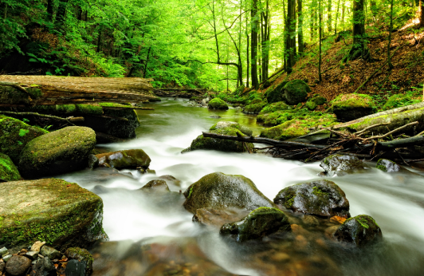
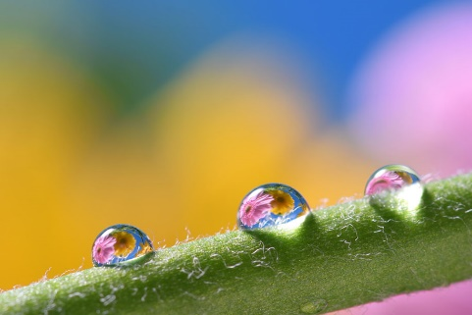
b
a

Fg. 1 (a) first picture; (b) second picture Cambria, 12 pt
Source: An Example of Source (Year of Source) Cambria, 10 pt

- Conclusion Cambria, Bold, 12 pt
Conclusion of your manuscript is defined what is novelty of your manuscript to knowledge and to fruitfulness of your community engagement program, benefit for society or community and contribution theoretic from your manuscript. Also, mention the recommendation from your manuscript related about community engagement. This conclusion is maximum 2 paragraph.

Acknowledgements Cambria, Bold, 12 pt
Acknowledgements on this manuscript at the end of the manuscript before the references and do not, therefor, include them on the title page or otherwise. List on this tab those individuals or company that provided help during your research. The example of providing your research, e.g., providing language help, writing assistance, data collect, proof reading the article, etc.

References Cambria, Bold, 12 pt
References of your manuscript must be up to date (in the last of 5 to 10 years and minimum of 20 references that 80% of the references is from primary sources/journal) and your reference can be accessed by anyone.
Format of the references for submitting manuscript on this journal with style of APA, which can be done in MS Word. Reference of your manuscript is organized alphabetically. Meanwhile, references should be in APA style constructed with Mendeley. For more information, please check https://open.mendeley.com/use-citation-style/apa. Here are example references format with style of APA.

Journal article:
Bhuvaneswari, K., Geethalakshmi, V., Lakshmanan, A., Srinivasan, R., & Sekhar, N. U. (2013). The impact of El Nino/ Southern Oscillation on hydrology and rice productivity in the Cauvery Basin, India: Application of the soil and water assessment tool. Weather and Climate Extremes, 2, 39-47.
Brennan, M. A., & Israel, G. D. (2008). The power of community. Community Development, 39(1), 82-97.
Book:
McKibbin, B. (2007). Deep economy: The wealth of communities and the durable future. New York: Times Books/Henry Hold and Co.
Chapter in an edited book:
Pigg, K. E., & Bradshaw, T. K., (2003). Catalytic community development: A theory of practice for changing rural society. In D. L. Brown & L. E. Swanson (Eds.), Challenges for rural America in the twenty-first century (pp. 385-396). University Park, PA: Pennsylvania State University Press.

Internet source
U.S. Census Bureau. (2000). State and Country QuickFacts. Washington, D.C.: United States Bureau of the Census. Retrieved November 7, 2008, from http://quickfacts.census.gov/qfd/

